Michael and Ann Sutton Research Scholarship Application
Deadline: January 31st, 2023

Name: Jackie Wang
Mailing Address: 100 Miles Park Dr, Columbia, SC 29223
Email: jackiew@email.sc.edu
Department: Computer Engineering

Member of Pi Tau Sigma, ME Honor Society (yes/no)?
no

Current GPA: 4.0

Request for Renewal of Previous Award (yes/no)?
no

Proposed faculty mentor for research (if identified):
Professor Austin Downey

Proposed method for disseminating research finding (e.g. write a conference or journal
paper with mentor, present at a national conference or a local conference, present to joint
meeting of Pi Tau Sigma and ASME Student Chapter):
A paper with Professor Downey regarding the research project or a future paper that will use the results of this project.

Please generate a single PDF document that contains, in the following order:
- This form as a cover page.
- A short statement of less than one page describing briefly the research to be performed your motivation for doing research. If the request is for conference travel or another activity, please describe the benefits of the activity to your chosen career path or goals. Figures and graphics are highly encouraged.
- A 1-page biosketch (résumé) that identifies any previous research activities. Note that no previous research activities are required for this award.

NMR: Advanced Sine Wave Generation and Analysis for Particle Concentration Measurement and Fuel Classification
Jackie Wang, Computer Engineering; Professor Austin Downey, College of Engineering and Computing

Data collected in particle analysis via nuclear magnetic resonance (NMR) are extremely insightful as it can help determine the chemical composition of a sample. This process is relatively efficient and accurate as demonstrated in previous research associated with ARTS-Lab conducted by Jacob Martin and in cooperation with Austin Downey and Sang Hee Won. Through their research using the ARTS-Lab's Compact NMR setup, they were able to determine that the device was able to identify the hydrogen content in gas turbine fuels with a maximum error of 0.7% and produce on average 4 scans per minute.
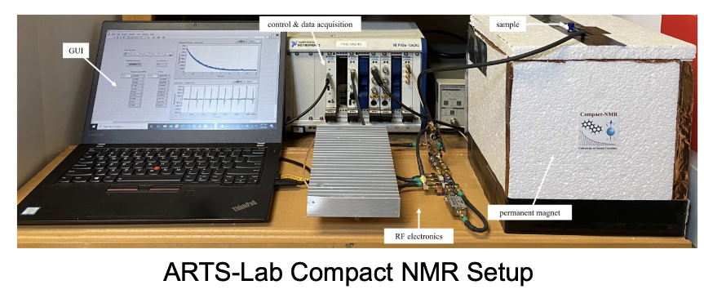
Despite this efficiency and accuracy, the setup has two main disadvantages of immobility and its exorbitant cost. The root of the disadvantages is the control and data acquisition device of the setup. This device is quite large and heavy, making the setup stationary as a result. Relocation of the device is also heavily discouraged due to its exorbitant price tag of $100,000. The cost of this device and its parts make it difficult to replace those parts in case they malfunction and difficult to replicate in case a duplicate of the setup is needed.
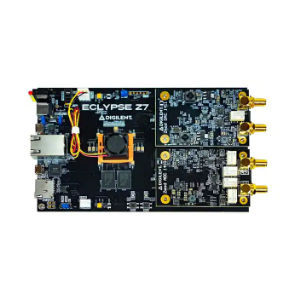Eclypse Z7 FPGA

To address the two disadvantages, this project aims to replace the control and data acquisition device with the $500 Eclypse Z7 FPGA. The difficulty of this project lies in development of the software that would enable this device to perform the same advanced sine waveform generation as the current setup. In the completion of this project, the ARTS-Lab Compact NMR setup will become more portable for on-site testing scenarios and cheaper to repair and replicate.

